**Project Design Phase-II**

**Data Flow Diagram & User Stories**

|  |  |
| --- | --- |
| Date | 03 October 2022 |
| Team ID | PNT2022TMID49885 |
| Project Name | News Tracker Application |
| Maximum Marks | 4 Marks |

**Data Flow Diagrams:**

A Data Flow Diagram (DFD) is a traditional visual representation of the information flows within a system. A neat and clear DFD can depict the right amount of the system requirement graphically. It shows how data enters and leaves the system, what changes the information, and where data is stored.

**DFD Level 0: DFD Level 1:** 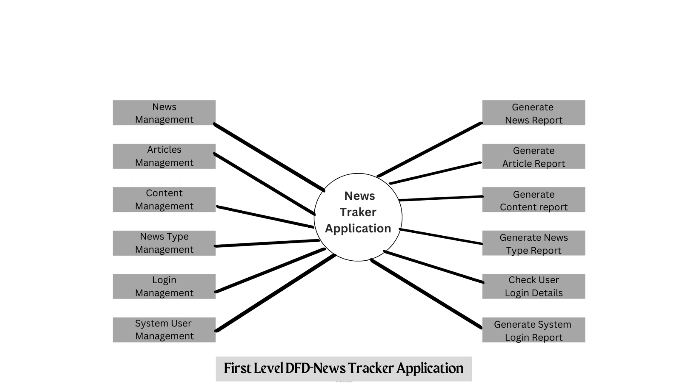

Content

Management

News Type

Management

Login Management

Articles

Management

Document

Management

Customer

Management

**Zero Level DFD-Customer Track System**

**User Stories**

| **User Type** | **Functional Requirement (Epic)** | **User Story Number** | **User Story / Task** | **Acceptance criteria** | **Priority** | **Release** |
| --- | --- | --- | --- | --- | --- | --- |
| Customer (Mobile user) | Registration | USN-1 | As a user, I can register for the application by entering my email, password, and confirming my password. | I can access my account / dashboard | High | Sprint-1 |
|  |  | USN-2 | As a user, I will receive confirmation email once I have registered for the application | I can receive confirmation email & click confirm | High | Sprint-1 |
|  |  | USN-3 | As a user, I can register for the application through Facebook | I can register & access the dashboard with Facebook Login | Low | Sprint-2 |
|  |  | USN-4 | As a user, I can register for the application through Gmail | I can register & access the dashboard with Gmail Login | Medium | Sprint-1 |
|  | Login | USN-5 | As a user, I can log into the application by entering email & password | I can login & access the application by entering email & password | High | Sprint-1 |
|  | Dashboard | USN-6 | As a user I can seed the details of the application through dashboard | I can known about the application features | Medium | Sprint-2 |
|  |  | USN-7 | As a user I need to enter the details for the subscription for news | I can need to enter the details for news subscription | High | Sprint-1 |
|  |  | USN-8 | As a user I can see other user feedback on the application in dashboard | I can view other user feedback to know about the application | Low | Sprint-4 |
|  |  | USN-9 | As a user I can view the rating of the news from the dashboard | I can know the rating of the news | Low | Spint-4 |
|  |  | USN-10 | As a user I can give feedback of the news in the dashboard | I can know the feedback of my experience in the pool | Medium | Sprint-3 |
|  |  | USN-11 | As a user I can logout from the dashboard after the completion of the work | I can logout from my id after the work completion | Medium | Sprint-1 |
| Customer (Web user) | Registration | USN-12 | As a user, I can register for the application by entering my email, password, and confirming my password. | I can access my account / dashboard | High | Sprint-1 |
|  |  | USN-13 | As a user, I will receive confirmation email once I have registered for the application | I can receive confirmation email & click confirm | High | Sprint-1 |
|  |  | USN-14 | As a user, I can register for the application through Facebook | I can register & access the dashboard with Facebook Login | Low | Sprint-2 |
|  |  | USN-15 | As a user, I can register for the application through Gmail | I can register & access the dashboard with Gmail Login | Medium | Sprint-1 |
|  | Login | USN-16 | As a user, I can log into the application by entering email & password | I can login & access the application by entering email & password | High | Sprint-1 |
|  | Dashboard | USN-17 | As a user I can seed the details of the application through dashboard | I can known about the application features | Medium | Sprint-2 |
|  |  | USN-18 | As a user I need to enter the details for the subscription for news | I can need to enter the details for news subscription | High | Sprint-1 |
|  |  | USN-19 | As a user I can see other user feedback on the application in dashboard | I can view other user feedback to know about the application | Low | Sprint-4 |
|  |  | USN-20 | As a user I can view the rating of the news from the dashboard | I can know the rating of the news | Low | Spint-4 |
|  |  | USN-21 | As a user I can give feedback of the news in the dashboard | I can know the feedback of my experience in the pool | Medium | Sprint-3 |
|  |  | USN-22 | As a user I can logout from the dashboard after the completion of the work | I can logout from my id after the work completion | Medium | Sprint-1 |
| Customer Care Executive | Customer support /help | USN-23 | As a support staff, I can provide FAQ for managing time and avoiding repeated questions | I can provide FAQ for avoiding repeated questions | High | Sprint - 4 |
|  |  | USN-24 | As a support staff, I need to respond quickly to the customer feedback | I need to respond quickly to the customer | Medium | Sprint - 2 |
|  |  | USN-25 | As a support staff, I can solve the problem of the customer for their satisfaction | I can solve the problems faced by the customers | High | Sprint - 1 |
|  |  | USN-26 | As a support staff, I need good communication skills to manage the customer | I need good communication skills to manage customer | Medium | Sprint - 1 |
| Administrator | Login | USN-27 | As an admin, I can login to the admin page through username and password to manage the tasks | I can login to the admin page through username and password | High | Sprint - 3 |
|  | Database | USN-28 | As an admin, I need to manage the database for better performance | I can manage the database by accessing it | Medium | Sprint - 4 |
|  | Dashboard | USN-29 | As an admin, I can add or remove any customer by noticing their actions | I can add or remove the customers | Medium | Sprint - 4 |
|  |  | USN-30 | As an admin, I can manage user feedback from the admin page | I can manage user feedback from admin page | Low | Sprint - 4 |
|  |  | USN-31 | As an admin, I can manage all the features of the application for better customer use | I can manage all the application features for better usability of the customer | High | Sprint -4 |